**Practical – 6**

**Aim:** Find out the vulnerability of network and perform penetration testing using OpenVas.

* OpenVAS (Open Vulnerability Assessment System the name of the fork originally known as GNessUs) is a framework of several services and tools offering a vulnerability scanning and vulnerability management solution.
* Setup and Start OpenVAS

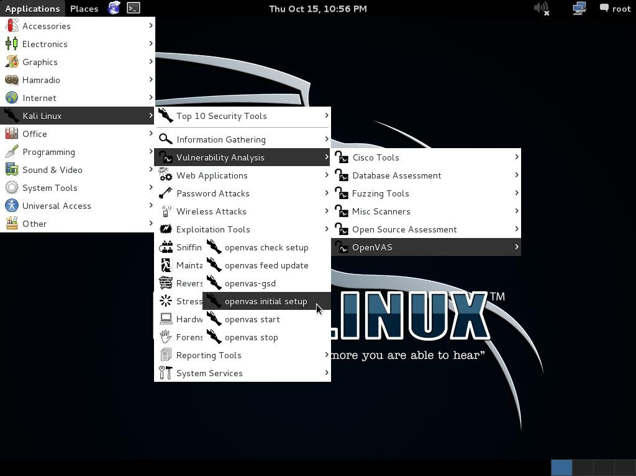On the first run of ovenvas on kali linux you need to run a setup script: apps > kali linux > vlnerability analysis > openvas > openvas initial setup

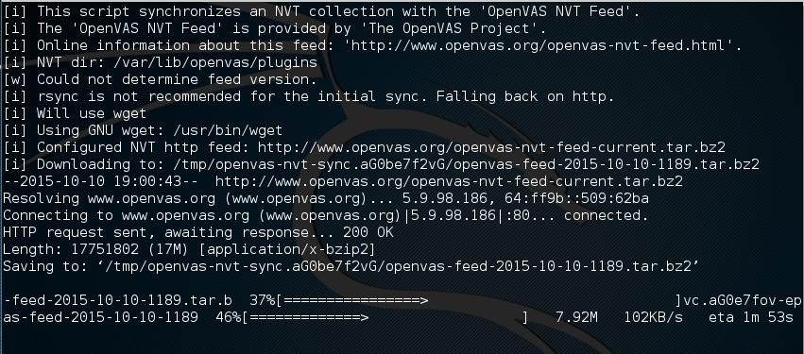

* We only need to run this once
* We will then need to start the openvas services:

apps > kali Linux > vlnerability analysis > openvas > start openvas

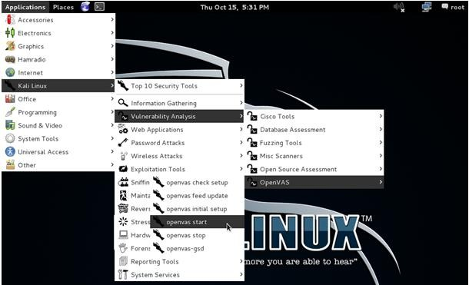

* 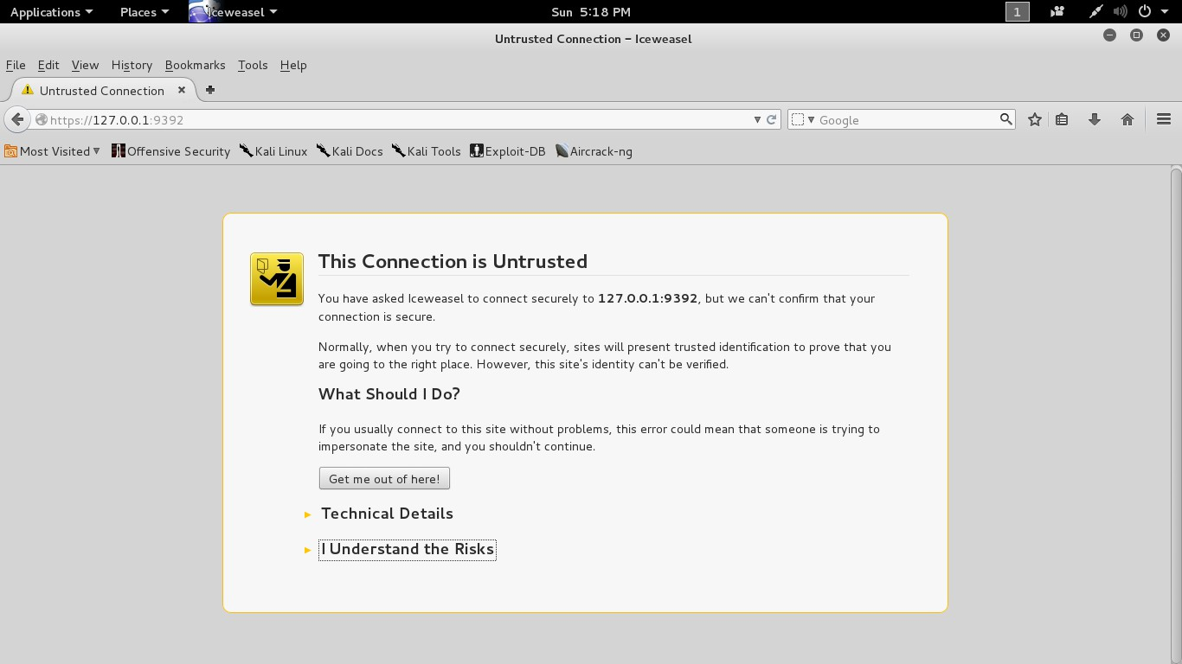Once openvas has started, open browser and point it to: https://127.0.0.1:9392
* After pointing to the address we found above page on screen we have to click on "I Understand the Risk" and "add the Exception" respectively.
* 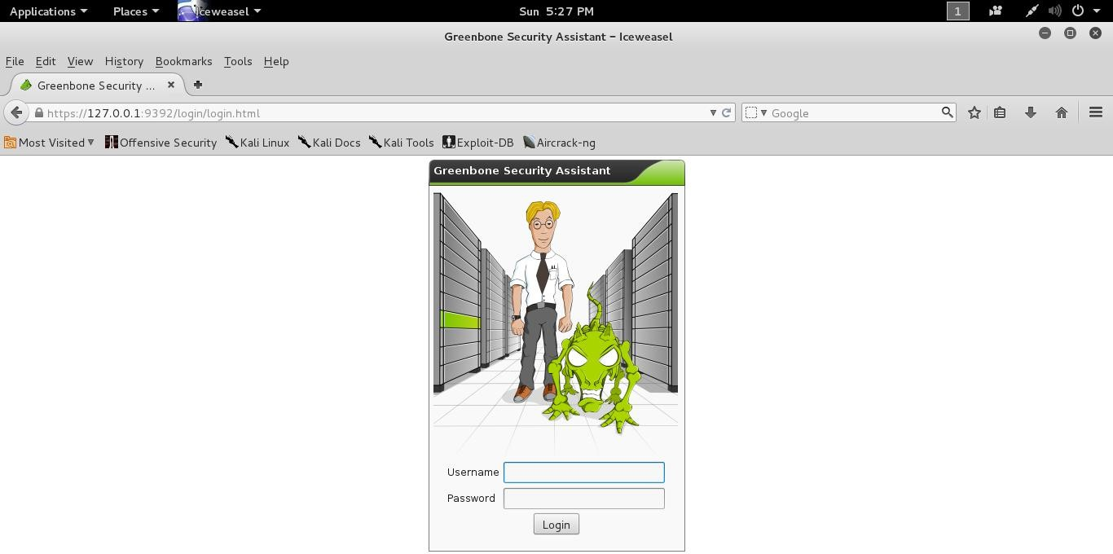After adding Exception this opens the ‘greenbone’ web interface for openvas as shown in bellow image.
* Login with default user name "admin" and password " password ".
* If Failed to login and found " login failed. omp service is down " then open terminal and fire bellow commands.

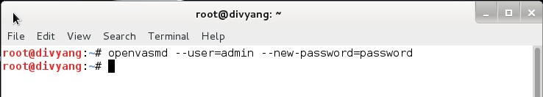openvasmd --user=admin --new-password=password

* 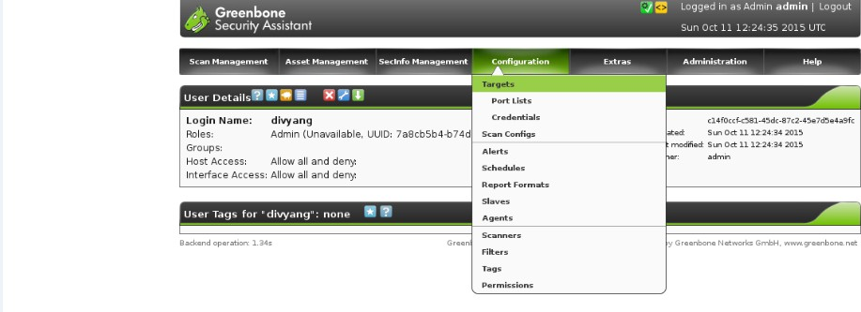Now go to Configuration > Targets
* 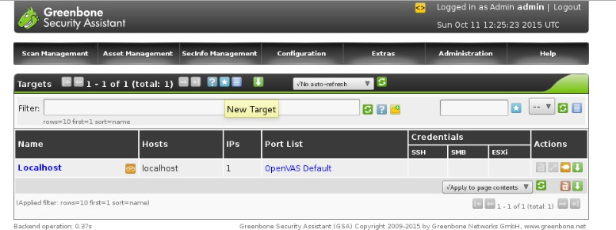Now Click On New Target As shown in Bellow Figure.
  + 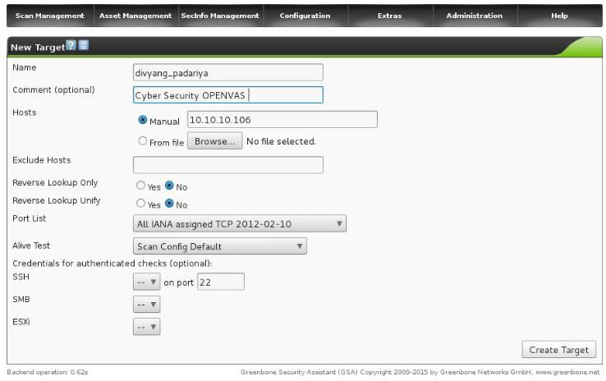Now Insert Details Which will required for target and then Click on "Create Target".
  + After Creating Target You Will Found following page which shows all the details about created target

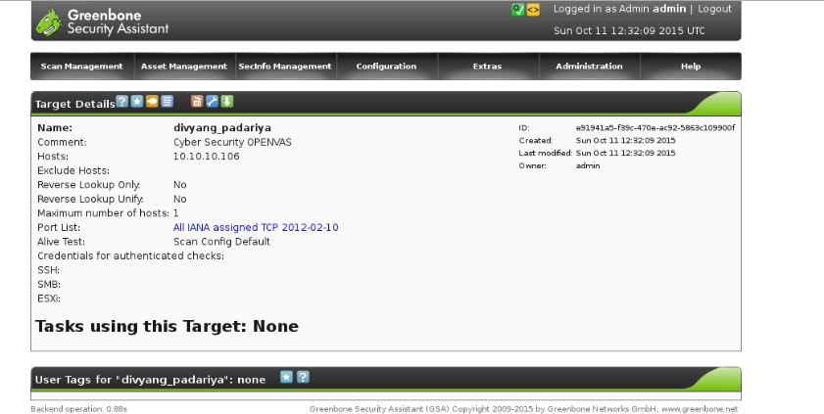

* + 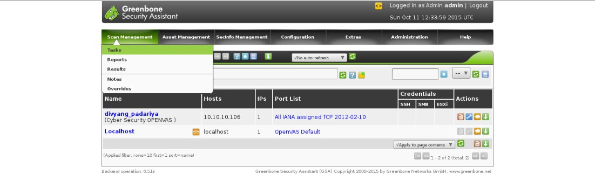Now Go to Scan Management >Tasks and create a new task
  + 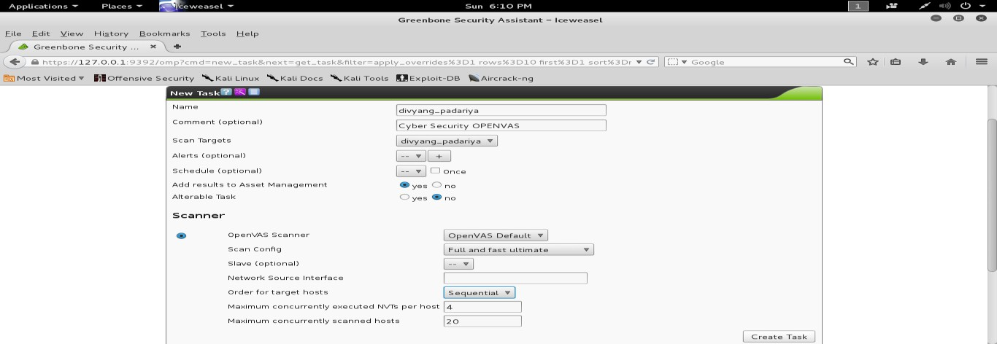Now add details for create a new task and click on "Create Task"
  + 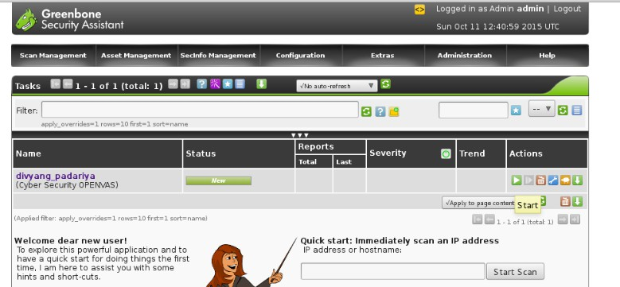After Creating New Task Go to the Tasks
* 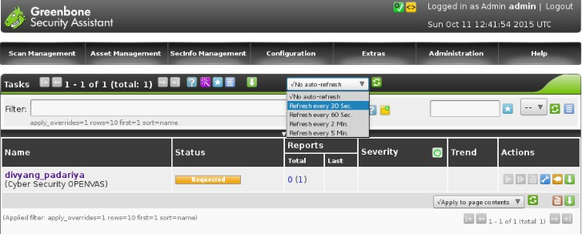Now Click on Start Button in "Actions" and by clicking on the start button Status change from "New" to "Requested".
* Now as shown in above picture click on dropdown list and select "Refresh every 30 sec" which will refresh the status of scanning on every 30 seconds.
* 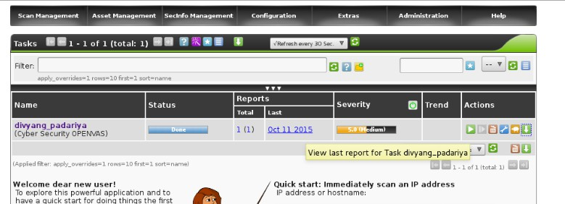After Completion of 100% scanning it shows "Done" status in Status portion.
* 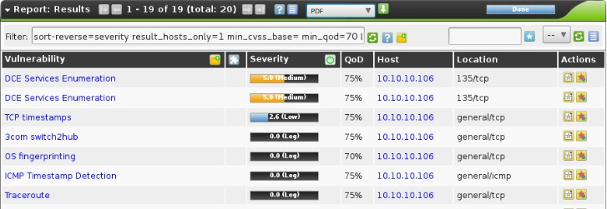Now as shown in Bellow picture we can see the details of scanning and we can also download generated report in various format.
* We can also create new User in open vas by following bellow pictures.
* Goto Assministration > users.

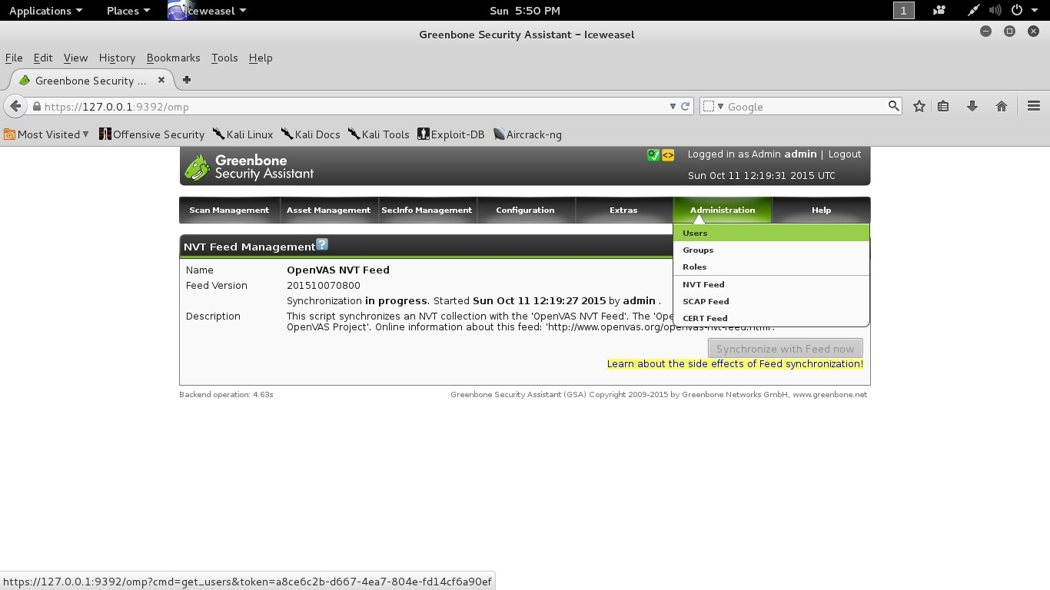

* + 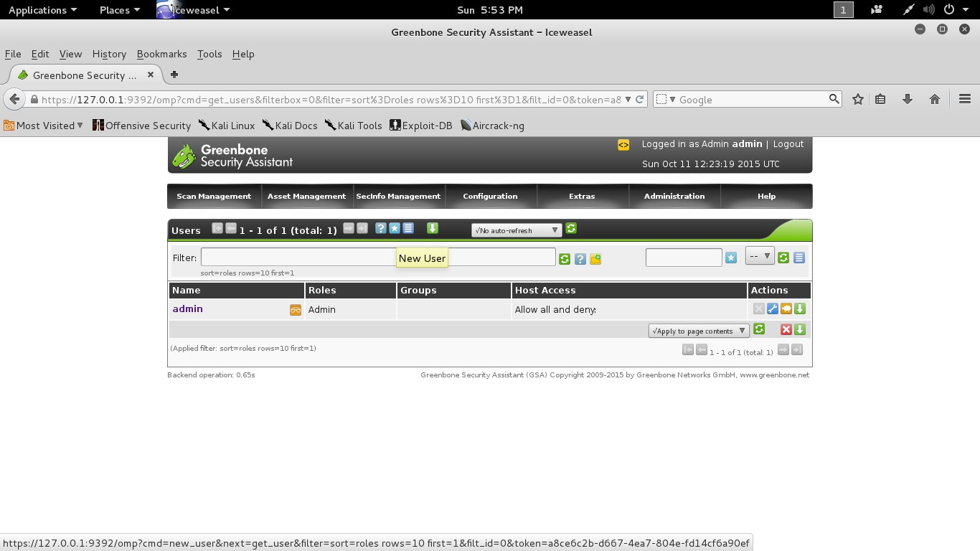Now Click on new User and fill details of new user.
    - By clicking on Create User new user created.

